Mt Lawley High School Chemistry 12 Redox Test

Name: __________________________


ALL of your answers and working should be written into this answer booklet.
This test consists of 15 multiple-choice questions, and 3 written questions.

Multiple-Choice
Record your answer by placing a cross (x) through the appropriate letter. If you change your mind then completely block out the error and cross your new answer.
eg | (a) | (b) | (c) | (x)

1. | (a) | (b) | (c) | (d)
2. | (a) | (b) | (c) | (d)
3. | (a) | (b) | (c) | (d)
4. | (a) | (b) | (c) | (d)
5. | (a) | (b) | (c) | (d)
6. | (a) | (b) | (c) | (d)
7. | (a) | (b) | (c) | (d)
8. | (a) | (b) | (c) | (d)
9. | (a) | (b) | (c) | (d)
10. | (a) | (b) | (c) | (d)
11. | (a) | (b) | (c) | (d)
12. | (a) | (b) | (c) | (d)
13. | (a) | (b) | (c) | (d)
14. | (a) | (b) | (c) | (d)
15. | (a) | (b) | (c) | (d)

Section 2 – Written Section. –25 marks

Answer all questions in the spaces provided.

1. Give balanced ionic equations for any reactions, which occur in the following experiments.

Describe observations such as colour change, precipitate formation, and gas evolution etc resulting from the chemical reaction.

- A piece of zinc metal is placed in a concentrated solution of copper (II) sulfate.
Equation/s:

Observations:

(2 marks)

- Acidified potassium permanganate solution is added to iron (II) ammonium sulfate solution (ie Fe(NH₄)₂(SO₄)₂ NB: Only the Fe²⁺ from this compound is involved in the reaction.)
Equation/s:

Observations:

(2 marks)

- Acidified potassium dichromate oxidises sulfur dioxide.
Equation/s:

Observations:

(2 marks)

- A wine sample is treated with potassium hydroxide to free any sulfur dioxide that has combined with other components in the wine. Then after sufficient time it is acidified with sulfuric acid. To determine the sulfur dioxide content of the wine it is titrated with standard iodine solution, using starch as an indicator.

Give the equation and observations for the titration. ie the reaction between the iodine and the sulfur dioxide.
Equation/s:

Observations:

(2 marks)
2. (a) Label the diagram of the blast furnace.

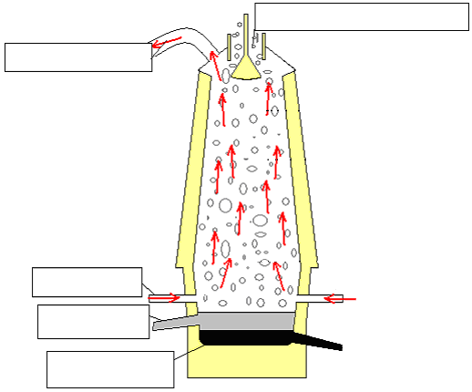

(b) Describe, with the aid of chemical equations, the various stages in the extraction of iron from iron ore in the blast furnace.

(3 marks)
3 A 2.050g sample of haematite (mainly Fe₂O₃) was dissolved in sulfuric acid and diluted to 250.0mL. A 25.0mL sample of the diluted solution was treated with just enough zinc to reduce the iron (III) ions to iron (II) ions. The 25.00mL sample was then titrated with 0.0212molL⁻¹ potassium permanganate solution. A volume of 23.40mL of KMnO₄ solution was needed to the end point.

- Using appropriate half equations, write a balanced equation for the oxidation of the Fe²⁺ ions by the permanganate solution.

- Calculate the number of moles of potassium permanganate used in each titration.

- Calculate the number of moles of Fe²⁺ in the 25.00mL sample.

- Calculate the number of moles of iron in the 250.0mL solution.

- Calculate the mass of Fe₂O₃ in the 2.050g sample of haematite, and then what percentage of the haematite is Fe₂O₃.

(5 marks)

